Preparation of Project Technical Reports for the LASC
Team Equipe Rocket Project Technical Report for the 2022 LASC
First A. Author and Second B. Author Jr.
Business or Academic Affiliation’s Full Name 1, City, State, Zip Code, Country
Third C. Author
Business or Academic Affiliation’s Full Name 2, City, Province, Zip Code, Country
Fourth D. Author
Business or Academic Affiliation’s Full Name 3, City, State, Zip Code, Country
These instructions are based on the guidelines for preparing papers for AIAA Technical Papers. The Latin American Space Challenge is NOT an AIAA conference, therefore while this document is copied from the AIAA Journal Article Template/Style Guide, the footer is changed to “The Latin American Space Challenge”. Submission procedures and required content of the LASC Project Technical Report are contained in Section 8.4 of the LASC Rules & Requirements Document. Use this document as a template if you are using Microsoft Word 2001 or later for Windows, or Word X or later for Mac OS X. Otherwise, use this document as an instruction set. Define all symbols used in the abstract. Do not cite references in the abstract. The footnote on the first page should list each author’s title. Advising Faculty should not be authors.
- Nomenclature
A = amplitude of oscillation
a = cylinder diameter
C_{p} = pressure coefficient
Cx = force coefficient in the x direction
Cy = force coefficient in the y direction
c = chord
dt = time step
Fx = X component of the resultant pressure force acting on the vehicle
Fy = Y component of the resultant pressure force acting on the vehicle
f, g = generic functions
h = height
i = time index during navigation
j = waypoint index
K = trailing-edge (TE) nondimensional angular deflection rate
vt = terminal speed (m/s)
Wt = total rocket weight (N)
S = parachute base area (m²)
𝜌 = air density (kg/m³)
Cd = drag coefficiente
g = gravitational acceleration (m/s²)
𝜌t = fabric density (g/m²)
L = paracord length (m)
Db = base diameter (m)
Tt = total tension (N)
Ty = vertical total tension (N)
mp = parachute mass (kg)
β = angle between parachute radius and paracord length (degree)

- Report Body
          - Abstract

          - Introduction

The avionics system, as depicted in previous reports, has the main function to acquire, communicate and log flight data as well as controlling the activation of the parachute and the rocket motor in order to have a complete monitoring and control of the vehicle throughout its entire trajectory.
In order to achieve this goal it was researched for electronic components and modules which would be capable and have operating range for the competition requirements, and how to properly install them and read their readings.

          - System Architecture Review
The boards which will be aboard of the rocket body were designed in a circular shape with 95mm in diameter to reduce installation complexity, being then able to be placed inside a cylindrical chamber and then fixed in any determined position along the inside of the body of the rocket.
To protect the electronics from humid environments, it was projected a sealed chamber, however, it posed a major flaw regarding the operation of some components which, due to requiring having external connections, were moved to a board external to the mentioned chamber (Recovery Board). It also required an external board for the activation of the rocket motor.
For the following boards were researched their components capabilities and measured its current consumption according to their corresponding datasheets, the referenced battery used on this analysis is a standard 9V battery with a capacity of 450mAh.
The boards were produced by an iron perchloride corrosion process on phenolite plates with the trails marked on the copper surface. Due to that, the trails were defined to have a width of 0,75mm to endure through the entire process.

- Internal Boards
This contains the main systems of the rocket, capable of obtaining its acceleration, rotation, position and temperature of the motor to communicate via radio frequency and log it on a micro sd card. Each board has approximately 30mm in height and will be mounted on top of one another by its connectors, which can be seen in detail on the figures at the end of this subtopic.
Below is listed the average current consumption of each component and the duration of the battery.

Component | Current Consumption [mA]
Atmega328p-pu | 16,43
MPU-9250 | 3,7
MAX6675 | 50
GPS NEO-6M | 67
HC-05 | 30
MicroSD Card Adapter | 30
Lora 433MHz E32 433T 30D | 106
Total [mA] | 303,13
Capacidade da Bateria [mAh] | 450
Duração [h] | 1,485
Table 1 Current Consumption of the internal boards.
The power supply board consists of a pair of lm2596 which are step down regulators, delivering 3.3V and 5V to the other boards inside the rocket, a battery of 9V which is going to power the other boards. The power supply board has a safety system implemented, required by LASC competition, which only permits the battery to supply current when a connected jumper is cut or removed. This board will be placed on top of all the others due to the necessity to being close to the battery which can’t be exposed to the high temperatures of the motor placed below the entire avionics system.
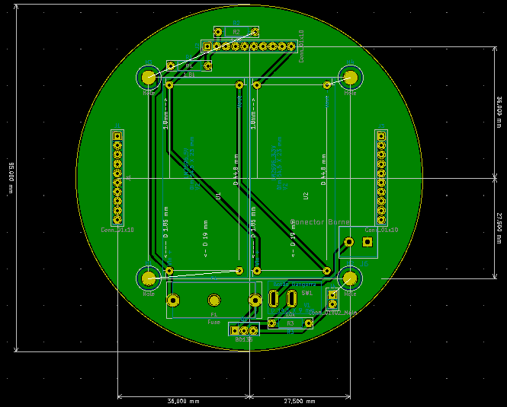
Fig. 1 PCB model of the Power Supply board.

The board computer board is the second from top to bottom on this structure and has all the data processing and programs for correct operation installed on an Atmega328p-pu microprocessor supplied with 5V. After obtaining all data provided by the sensors it will register them with a refresh rate of approximately 0,5 seconds on a micro SD card via the adapter connected on the same board communicating via UART.
This part of the system also has an experiment implemented to acquire information related to the operation of two batteries, a 3V Litium Cr2025 battery and a 1,45V Zn-O battery, both connected to the analog pins of the microprocessor by a 220Ω resistance. The reading is made through an internal A/D conversion and the read values will be compared to their stability and behavior throughout the flight.
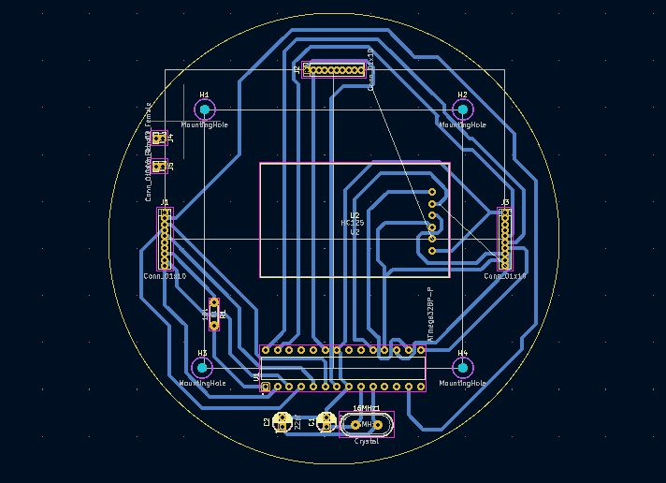
Fig. 2 PCB model of the On-Board Computer board.

The telemetry board is the third from top to bottom and is responsible for a radiofrequency communication with the transmitter board on ground via a Lora 433MHz E32 433T 30D, which has a maximum range of 3km, this model was selected due to the Lora 433MHz E32 433T 20D model having a maximum range of 1km and could have the rocket out of range when approximating its apogee.
In this board is also implemented a GPS NEO-6M module which has the capability of acquiring the rocket’s global coordinates and altitude provided by a connected GPS system. However, the altitude of this module is only used to regulate the initial readings of the barometer on a setup stage.
Both components communicate via UART with the microprocessor.
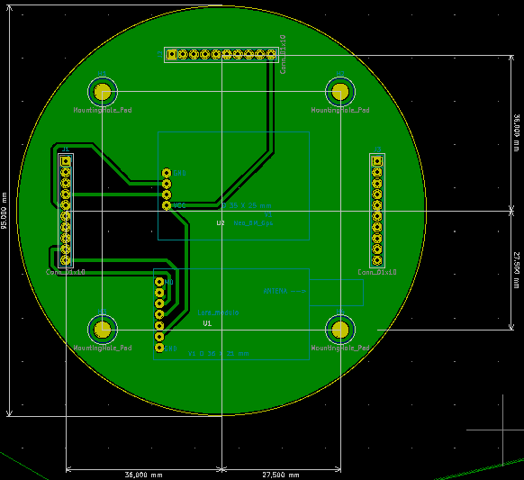
Fig. 3 PCB model of the Telecommunication board.
The telemetry board is the last one of the internal systems, being at the bottom of the avionics due to it’s necessity to be close to the rocket motor. This system has a MAX6675 module with a termopar couple wire to measure the motor temperature. Its operating temperature range is from -20°C to +85°C converted in a digital value by the module itself. This module is set to communicate via SPI.
The board also has a MPU-9250 gyroscope module, capable of obtaining rotations of ±2000 º/s, its accelerometer has a capacity range of ±16 g and its magnetometer of ±4800 µT, which is set to communicate via I2C. There’s also a HC-05 (Communicating via UART) bluetooth module set as master to receive data from another module on the recovery board.
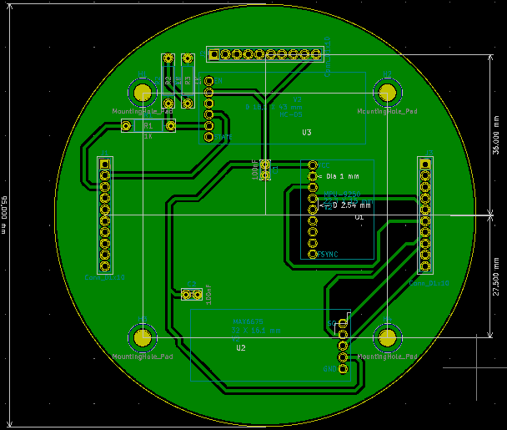
Fig. 4 PCB model of the Telemetry board.

- Recovery Board
As mentioned above, this board was necessary due to the requirements of some components, those being the BMP280 barometer, which only operates properly when exposed to the external atmosphere, and the parachute activation system, which needs a connection to the parachute storage chamber on the rocket..
The BMP280 barometer has a pressure range of 300hPa to 1100hPa, however its initial condition has to be set with the local pressure conditions provided by local forecast for precise pressure to altitude conversion. This module, as well as the slave HC-05 module sending data to the master HC-05 on the internal boards, is set to communicate by a UART protocol.
The parachute activation system will be composed of a lamp filament which upon the activation of a electronic switch with the BD135 transistor will have a maximum current of 0,5A passing through it generating heat according to the Joule’s law.
 $P=I²×R$ (1)
As the supply voltage is set to a maximum of 5V and the current has a limit due to the transistor, the following formula can be depicted.
$Pmax=I×V = 0,5A×5V=2,5W$ (1)
The value above ignores loss in the wires and components other than the lamp filament. Ignoring those losses the $Pmax$ value corresponds to the maximum value of heat transferred through the filament, the maximum temperature can be calculated by the following formula.
$ΔT = Req×Pmax$ (1)
However the conditions like the convection and conduction coefficients which are necessary to calculate $Req$ are yet unknown and thus the value of the final temperature can’t yet be calculated.
Below is listed the average current consumption of each component and the duration of the battery, the consumption of the parachute activation system is ignored due to it only being active for a short time duration.

Component | Current Consumption [mA]
Atmega328p-pu | 16,43
HC-05 | 30
BMP280 | 0,0027
Total [mA] | 46,4327
Capacidade da Bateria [mAh] | 450
Duração [h] | 9,691
Table 2 Recovery Board power consumption.
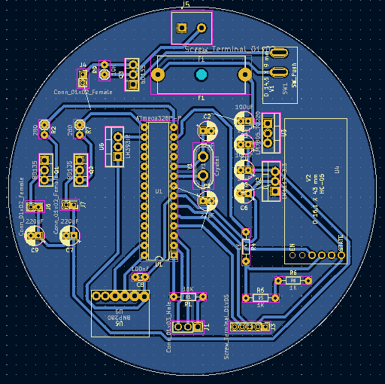
Fig. 5 PCB model of the Recovery board.

- Ignition system
For the activation of the rocket motor at a safe distance, it was implemented two boards communicating via radio frequency with a pair of Lora 433MHz E32 433T 20D, which have a maximum range of 1km. For safety, the transmitter will only send the activating signal, composed of a specific password, when 3 switches are switched and a button is pushed. The receiver will then read the signal and verify if the password matches with one pre-defined to only then activate the relay and ignite the motor, this is implemented to reduce the chance of misfire due to interference.
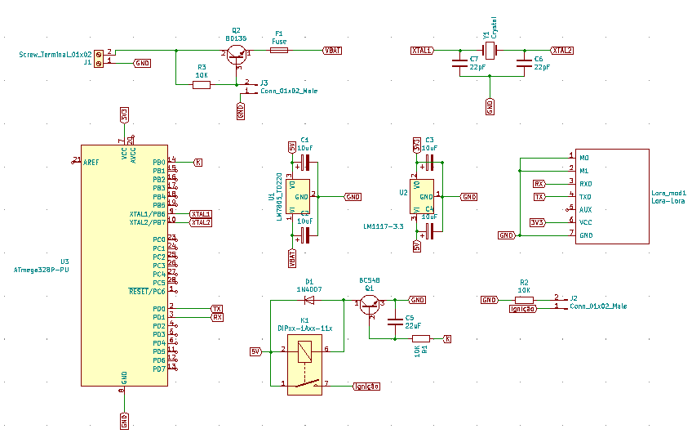
Fig. 6 Schematic of the Ignition Receiver board.
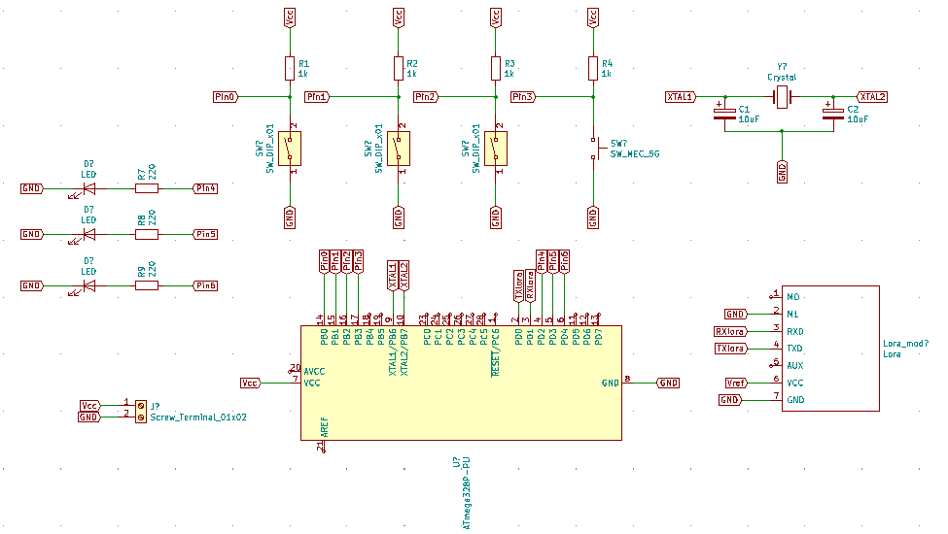
Fig. 7 Schematic of the Ignition Transmitter board.
- Static Stand
The static stand, which will be responsible for static tests of the motor force during its ignition, will be built around a arduino uno module and a Hx711 module connected to four piezoelectric sensors which can measure up to 200kg. The sensors will be connected in parallel to the E+ and E- terminals of the Hx711 module, which will then have is S+, S-, A+ and A- terminals connected to the arduino as shown on the figure below
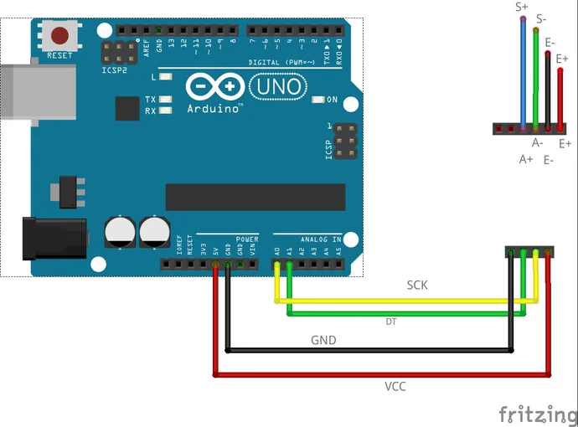
Fig. 8 Schematic of the static stand arduino module connections^9.
Its power will be supplied by the arduino module connected to a computer for the reading of the values, which will be converted from analog to digital on the arduino, the analog data is acquired via spi communication between the modules. The output analog value will vary from 0 to 5V which will be converted on the arduino to a digital value varying between 0 and 1023 corresponding to the mass of 0 to 200kg equivalent to the force applied by the motor.

          - Mission Concept of Operations Overview
          - Conclusion and Lessons Learned
- Required Report Appendices
          - System Weights, Measures and Performance Data
          - Project Test Reports
          - Hazard Analysis
          - Risk Assessment
          - Assembly, Preflight, Launch, and Recovery Checklists
          - Engineering Drawings
- List of References
[1] MAX6675 Cold-Junction-Compensated K-Thermocoupleto-Digital Converter (0°C to +1024°C). URL: https://datasheets.maximintegrated.com/en/ds/MAX6675.pdf [retrieved 22 April 2022].
Lora 433MHz E32 433T 30D https://www.ebyte.com/downpdf.aspx?id=108
Lora 433MHz E32 433T 20D https://www.ebyte.com/en/downpdf.aspx?id=660
NEO-6 u-blox 6 GPS Modules https://content.u-blox.com/sites/default/files/products/documents/NEO-6_DataSheet_%28GPS.G6-HW-09005%29.pdf?utm_source=en%2Fimages%2Fdownloads%2FProduct_Docs%2FNEO-6_DataSheet_%28GPS.G6-HW-09005%29.pdf
MPU-9250 Product Specification https://invensense.tdk.com/wp-content/uploads/2015/02/PS-MPU-9250A-01-v1.1.pdf
BMP280 Digital Pressure Sensor https://cdn-shop.adafruit.com/datasheets/BST-BMP280-DS001-11.pdf

ATMEGA328P-PU https://pdf1.alldatasheetpt.com/datasheet-pdf/view/392289/ATMEL/ATMEGA328P-PU.html
Adafruit Arduino Libraries https://learn.adafruit.com/adafruit-all-about-arduino-libraries-install-use

[9] Make Your Weighing Scale Hack Using Arduino and Hx711. URL: https://www.instructables.com/Make-your-weighing-scale-hack-using-arduino/

Insert Title, Department Name, and Address/Mail Stop for first author.
Insert Title, Department Name, and Address/Mail Stop for second author.
Insert Title, Department Name, and Address/Mail Stop for third author.
Insert Title, Department Name, and Address/Mail Stop for fourth author (etc.).

